|  |  |  |  |
| --- | --- | --- | --- |
|  | Bansilal Ramnath Agarwal Charitable Trust's  Vishwakarma Institute of Information Technology  **Department of**  **Artificial Intelligence and Data Science** | | |
| Student Name:Siddhesh Dilip Khairnar | | | |
| Class: SY | Division: B | | Roll No:272028 |
| Semester: III | | Academic Year:2022-23 | |
| Subject Name & Code: DBMS, ADUA21204 | | | |
| Title of Assignment:Design and Develops SQL DDL statements which demonstrate the use of SQL object such as Table | | | |
| Date of Performance: 30-07-2022 | | Date of Submission: 06-08-2022 | |

# Aim: Design and Develops SQL DDL statements which demonstrate the use of SQL object such as Table

**Problem Statement**:   
1. Create a table employee containing attributes such as (Emp_id, Emp_name, Emp_Salary, Emp_age)

2. Add column city into employee table.

3. Insert at least 5 records into the given table.

4. Truncate the records from the given table.

5. Again insert at least 5 records into the given table.

6. Drop the employee table.

7. Check existence of employee table after execution of drop command.

**Background information:**

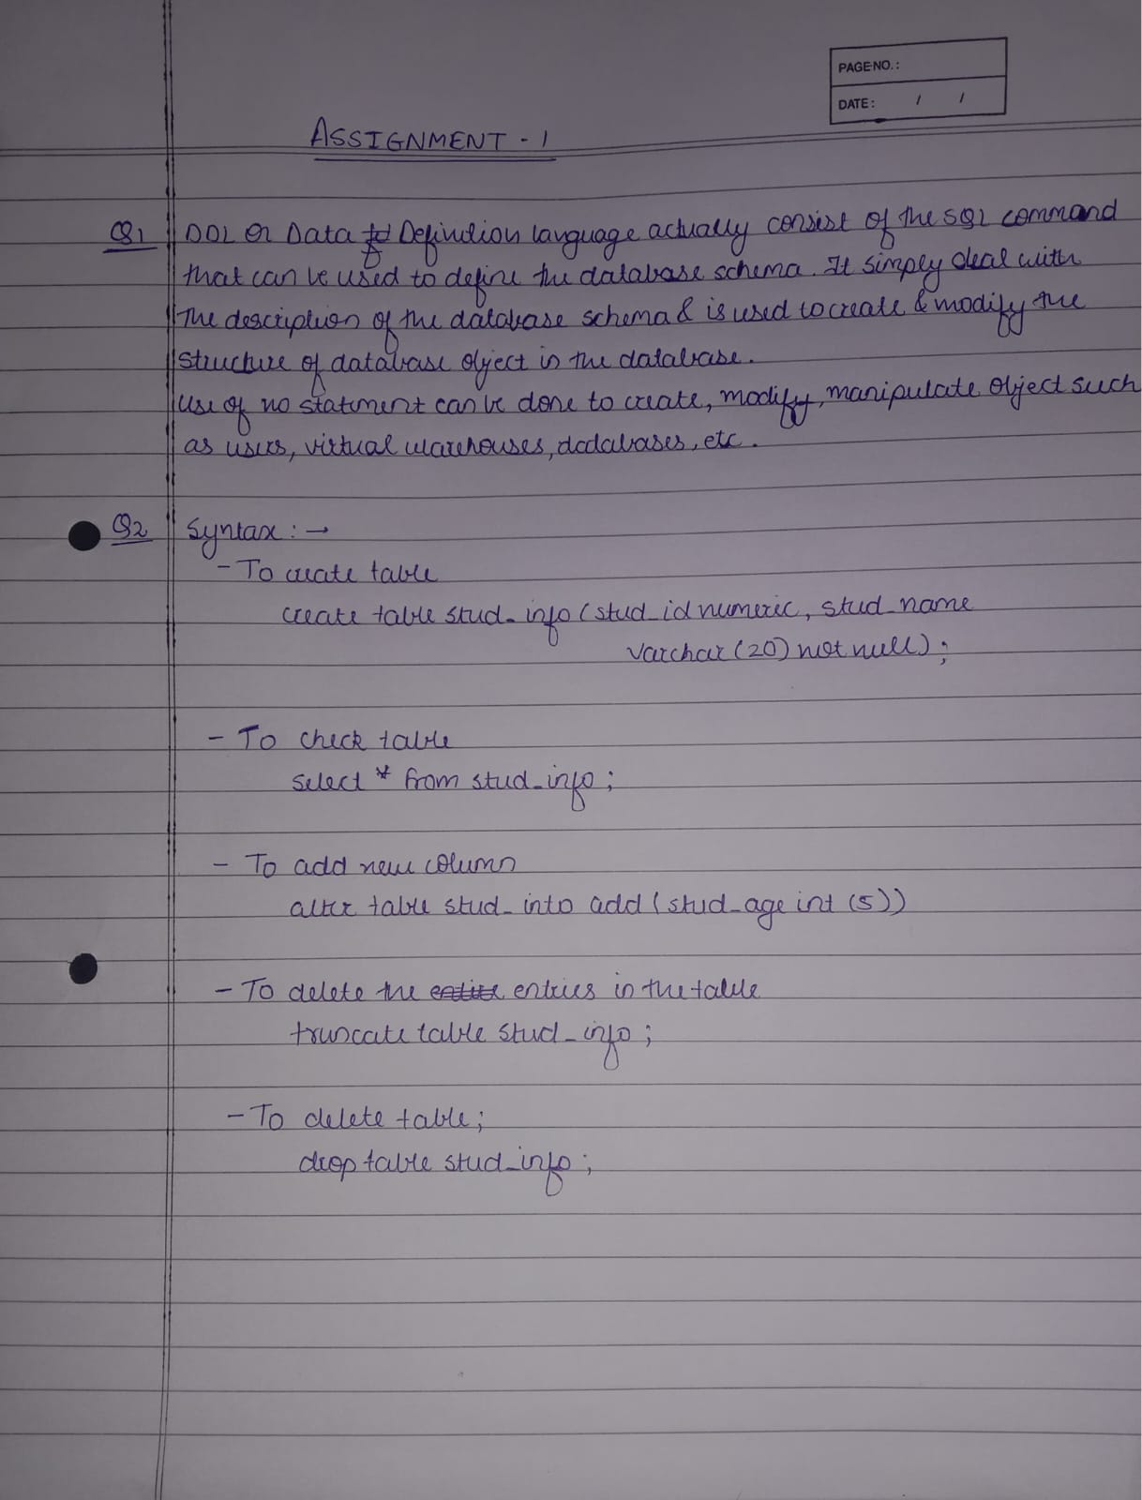

**Software Requirements**: MYSQL Shell

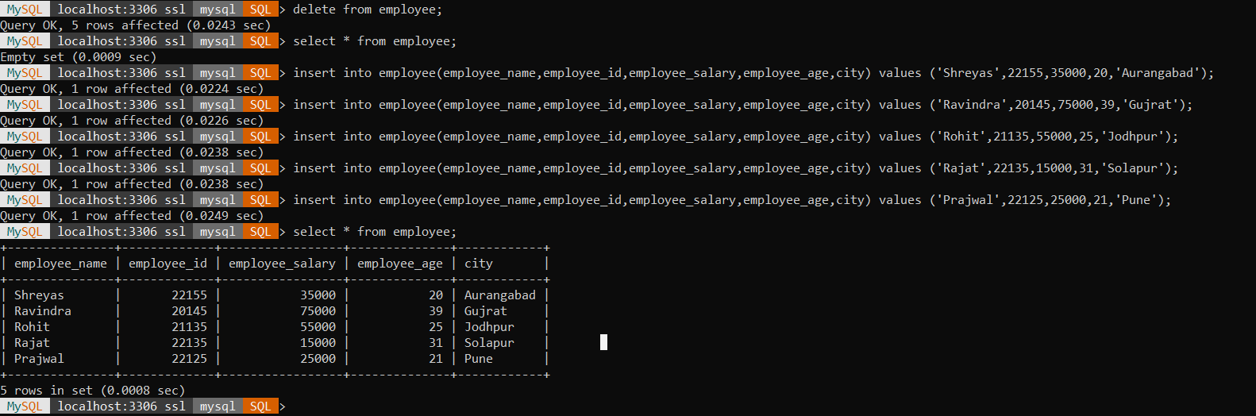**Program code with experimental result:**

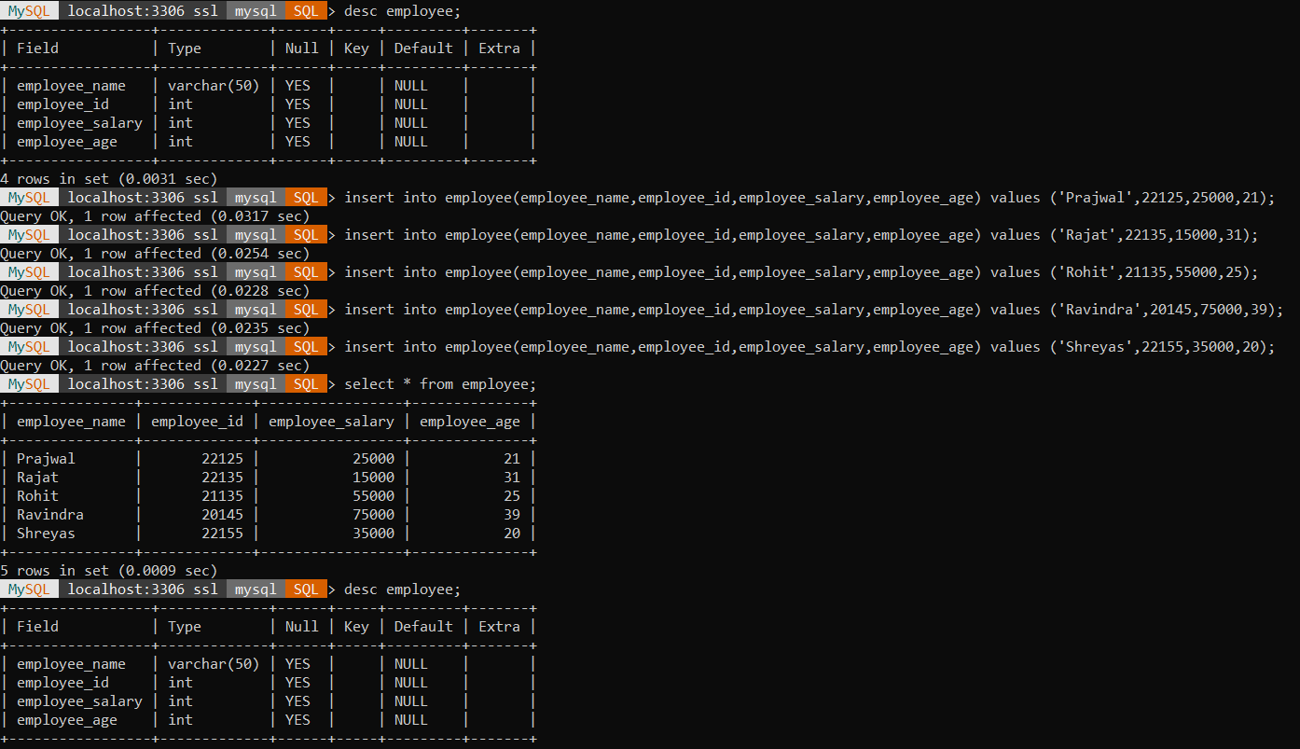

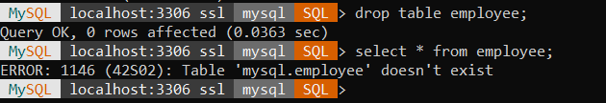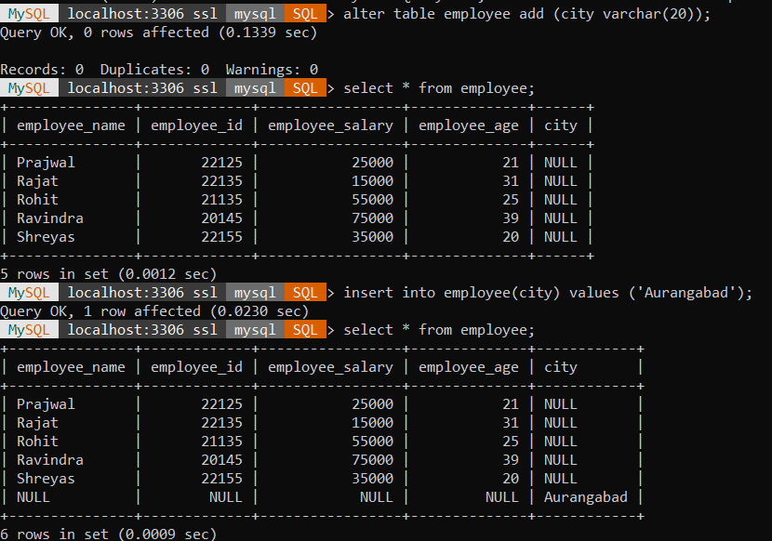

**Conclusion:** DDL in SQL is the foundation step and hence is very helpful for

future aspects like DML, TCL or DQL. So, the commands should be executed properly and used to perform operations like CREATE, ALTER, DROP, TRUNCATE, etc